**EXPERIMENT-5**

**Submitted by:**Ajay Kumar Tyagi  
500067403  
R171218008  
CSE-DevOps 2018-2022

**Aim:** To create Docker compose file and launch container using it.

**Procedure:**

**1)** First create a **docker-compose.yml** file and inside the file write the code as follows:  
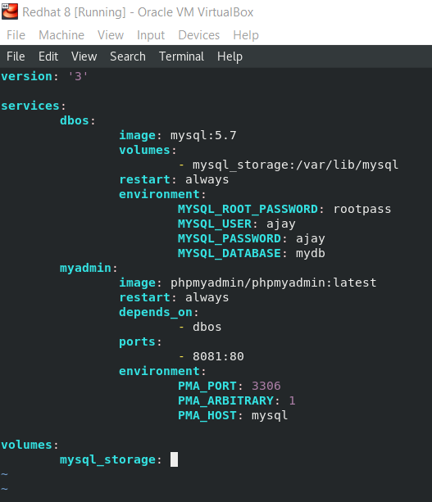

Here under **services**, we can write all the services we want to launch. Under every service, we have to give attributes such as **image**, **volume**, **ports**, **environment variables**, etc. Here environment variables are credentials for MySQL database.

**2)** After creating docker-compose file, use command  
**docker-compose up** to launch the architecture in one go. Use option **-d** to hide the terminal output.  
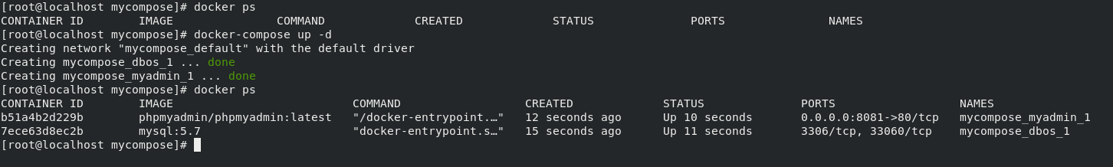

**3)** At last on your browser, open the container application to see the output.  
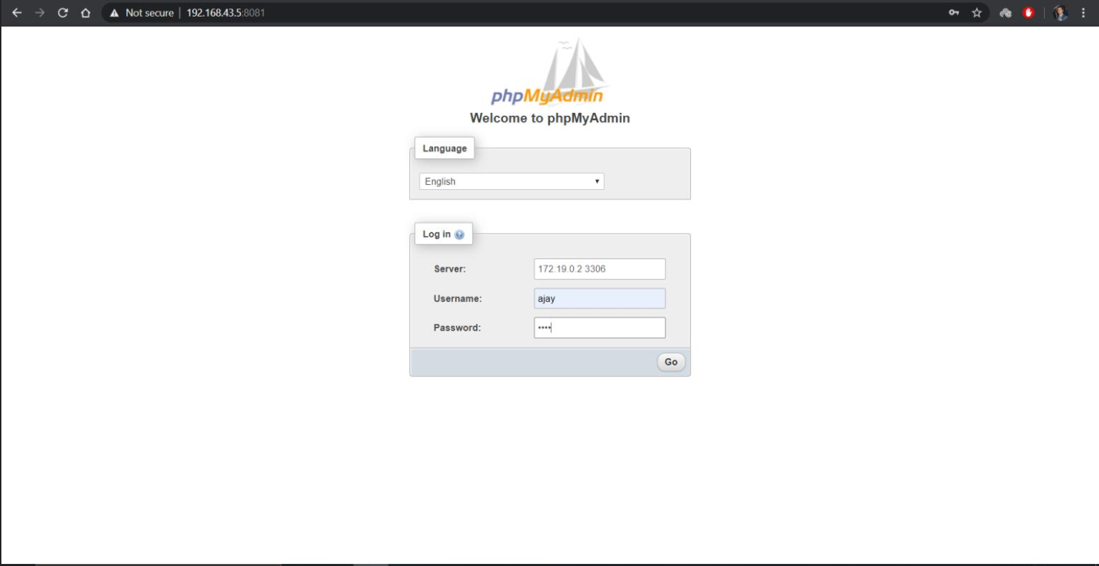

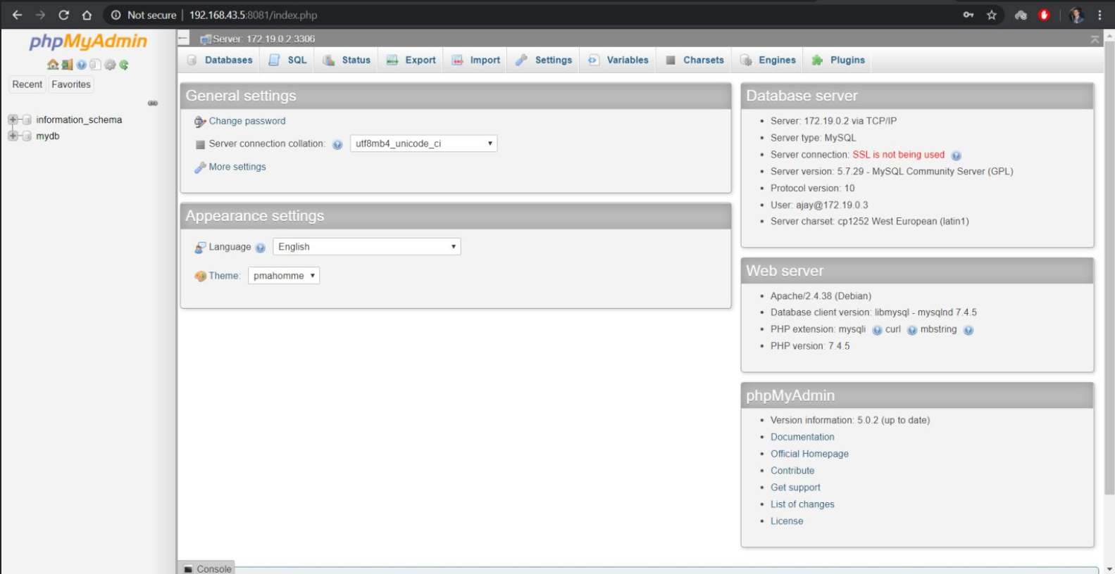

**4)** Use command **docker-compose down** to stop all your architecture in one go.  
